WARCRAFT 3

**GAME DESIGN DOCUMENT**

TREE TAG

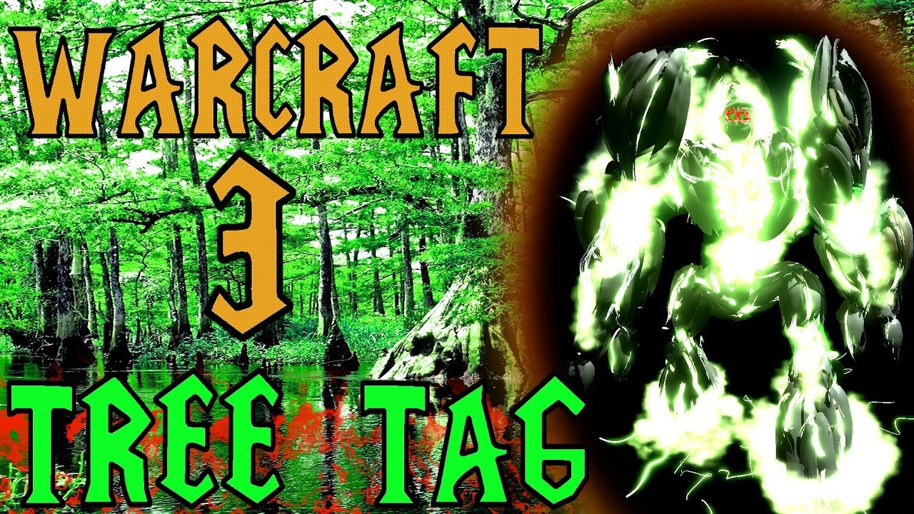

**Last Updated:**

28/11/21

**Prepared By:**

Lovro Kovačević

**TABLE OF CONTENTS**

Game Analysis 3

Mission Statement 3

Genre 3

Platforms 3

Target Audience 3

Storyline & Characters 4

Gameplay 5

Overview of Gameplay 5

Player Experience 5

Gameplay Guidelines 5

Game Objectives & Rewards 5

Gameplay Mechanics 5

Level Design 6

Control Scheme 7

Game Aesthetics & User Interface 7

Schedule & Tasks 8

# Game Analysis

Tree tag, as the name itself implies, is a game of a tag in the forest. We all played a game of tag with our friends, so you already know the basics, hide or be found. Game is played using the bird perspective with limited FOW (fog of war/filed of view) which makes it fun and challenging. The twist that makes it interesting is an addition of a few basic spells and base building and planning strategies. Game is played as a multiplayer game where there can be a total of 12 players of whom 3 are the infernals and 9 are ents. This can be arranged in any way that suits the count of players. For example if there are 7 people that want to play the game 3 of them can be infernals and 4 of them can be ents. The game has a timer of 45 minutes in which infernals must kill ents. If the timer runs out the ents are winners.

# Mission Statement

Tree Tag, the eternal war for the forest. Choose between ents or infernals. As ent you have to survive for 45 minutes in the forest and hide from the infernals. As infernal you have to kill all ents before the time runs out. Find your place on the map, make base and defend against infernals or just burn and kill everything as infernal.

# Genre

The main genre of Tree tag is strategy with the basics of action, atmospheric, management of the resources, exploration elements. As already mentioned, the game is played using birds perspective or top down view. Tree tag is also a multiplayer experience with numbers of player ranging anywhere for a minimum of 2 to a maximum of 12 players.

# Platforms

Tree tag is available on Microsoft Windows.

# Target Audience

Tree tag can be played and is targeted to everyone. Game is simple, action packed and appropriate for all ages. Those who will fall in love with the game most are hide n seek and like-minded genre enjoyers. Tree tag does not consist of religion or other potential harmful items, characters or scenarios so it is appropriate for all regions

# Storyline & Characters

As the game itself is a multiplayer experience the story of tree tag is not in the main focus. For that the principal of Tree tag is simple and basic. Infernals want to destroy, kill and burn the forest and its inhabitants while ents are its defenders and protectors. In 45 minutes the story of forest will be written. Either its destroyed or it will stand forever without the threat of infernals.

|  |  |  |  |
| --- | --- | --- | --- |
| Character | Description | Characteristics | Misc. Info |
| Ents | Playable characthers of the forest and hide faction.  Defenders of the forest. They all have the same model with different colours based on what colour player chose in pre game menu. Their goal is to hide and defend from infernals. | Each ent has 6 identical abilities; summon building, blink, regrow tree, ungrow tree, destroy trees and true sight. All of the spells are available form the start of the game with the exception of true sight which is a ability that allows to see invisible items, traps or infernals and needs to be researched within your base. | Their movement speed is lower then infernals so they must focus on finding a good spot on the map to hide rather then to outrun the infernals. |
| Blaze (infernal) | First of the three internals is Blaze. A playable character which also shares the same model with other infernals but their colour scheme is different based on their main attribute. | Balzes attribute is agility which grants him grater movement speed then other infernals and also his attack speed. All infernals have different abilities with only the destroy trees ability that is shared by all. Blazes spells are ensnare, fire swarm, flames of speed and endurance aura. |  |
| Burnin | Second infernal is Burnin. His main attribute is strength which gives him a higher health. | Burnin spells are shockwave, command aura, immolation and avatar of fire. |  |
| Pyra | The last infernal is Pyra. Her attribute is intelligence which gives her increased mana and therefor she has easier time casting spells and abilities. | Pyra spells are fire elemental, lighting trap, brilliance aura and nuclear explosion. |  |
|  |  |  |  |
|  |  |  |  |
|  |  |  |  |

# Gameplay

## Overview of Gameplay

Tree tag is a custom map made and played in Warcraft 3 expansion Frozen throne and therefor its using that engine and its features like graphic schemes, top down view and its models for character’s, spells, etc. Beside from the game is unique and could be used as a standalone game as others game such as DOTA or Counter strike. Its unique mechanic is combination of Warcafts elements such as building, spell casting, attacking etc. and a classic game of tag. The game is currently only played on Windows but if its ever made into a standalone game it could also be ported to mobile and console platforms. In current state Tree Tag is a multiplayer only game.

## Player Experience

After the lobby of the game is filled with player and you chose who will play the infernals and ents the game takes you to a quick loading screen and then it starts. As ent you will see a forest in which you will be playing and you should immediately start looking for a spot to set up your base. You also have a minimap in the bottom left corner. The view you see is also shared among your allies so you all have the same view of the map and the minimap. This is where the team work aspect should be exploited. You should use your skills and building strategically to gain the upper hand in the battle of infernals who will be seeking you throughout the game. Your goal is to gather resources and fortify your base as hard as you can. If you get caught by infernal you go to „jail“ that is in the middle of the map from you can be saved by your fellow ent allies. Although beware, if infernals destroy you or your structures they will gain gold and experience which makes them stronger. As infernal you will have a delayed spawn time of 30 seconds. You have few shops around the map that can give you items like a crystal ball that reviles the part of the map or the mine that is invisible to ents unless they have a true sight. You buy these items using gold. Gold is gain passively thru time and also by destroying ents buildings and themselves. Your other resources is experience which you gain in the same way. Experience grants you spells and also their increased power. Your goal is to kill all the ents in 45 minutes.

## Game Objectives & Rewards

Tree tag is constant battle between players and time. As you find good hiding spot as ent you will start building your base. To do that you need resources. There are 3 main resources in the game and they are gold, wood and food. You gain these by building a resources storage which gives you wood, gold and food storage every 5 seconds based on how many of these you have. You can also upgrade these to give you even more resources. Even though you can make a infinite number of resources storage you should limit yourself as not to overuse your base space as you need it for other budlings too. One of those budlings is tree of life which you can use to make soldiers. The other one is a pissed off tree that attacks infernals on sight. Building smart and planning ahead is a key to the victory. As mentioned above infernals gain passive income of gold which can be used for items but your main goal should be to gain in actively by destroying ents and their buildings. By doing that you buff yourself out of the control and wreak havoc in the forest. Difficulty of the game lies in the strategic planning of ents and teamwork of infernals which falls on the players themself. After the game has ended in either infernals or ents victory you will be presented with the scores of each player. All the actions that benefit you in game are scored and therefore your final score will be based on that. Even though final score is not that important as the outcome of the game it is a good indicator of the game styles of each player.

## Gameplay Mechanics

As is the nature of Warcraft 3 everything is controlled using your cursor. You move by right clicking on the map and you use your abilities by either pressing their icon and then where you want to use them or by using hotkeys. Both ents and infernals can attack trees to knock them over. As mentioned above there are unique spells and what exactly they do we will cover now.

**ENTS SPELLS**

|  |  |
| --- | --- |
| Spell name | Description |
| Summon building | Used for making buildings. Each one has set amount of resources you have to have before making them. |
| Blink | Short range teleport. |
| Regrow tree | Regrows one tree. Can be used to cover your tracks. |
| Ungrow tree | Destroys a tree. Can be used for opening paths in forest. |
| Destroy trees* | Destroys trees in a AOE (Area of effect) at the targeted location. Short range. |
| True sight | Passive spell that is not unlocked form the start. Can be unlocked later by upgrading certain aspects of a buildings. |
|  |  |

**INFERNALS SPELLS**

|  |  |
| --- | --- |
| **BLAZE** |  |
| Spell name | Description |
| Ensnare | Casts a web at the enemy unit. Duration 2 seconds. Upgrading the spell will increase its duration on times 3,4 and finally 5 seconds. |
| Fire swarm  Slika na kojoj se prikazuje tekst, na zatvorenom, zatvoreno  Opis je automatski generiran |  |
| Flames of speed  Slika na kojoj se prikazuje tekst, na zatvorenom  Opis je automatski generiran | **Slika na kojoj se prikazuje tekst  Opis je automatski generiran** |
| Endurance aura  Slika na kojoj se prikazuje tekst, na zatvorenom  Opis je automatski generiran | Passive ability  Slika na kojoj se prikazuje tekst  Opis je automatski generiran |
| Destroy trees* |  |
|  |  |

|  |  |
| --- | --- |
| **BURNIN** |  |
| Spell name | Description |
| Shockwave  Slika na kojoj se prikazuje tekst, na zatvorenom  Opis je automatski generiran |  |
| Command aura  Slika na kojoj se prikazuje tekst, na zatvorenom, zatvoreno  Opis je automatski generiran | Passive |
| Immolation  Slika na kojoj se prikazuje tekst, tamno, zatvoreno, mutno  Opis je automatski generiran | Passive  Slika na kojoj se prikazuje tekst  Opis je automatski generiran |
| Avatar of fire  Slika na kojoj se prikazuje tekst, na zatvorenom  Opis je automatski generiran | **Slika na kojoj se prikazuje tekst  Opis je automatski generiran** |
| Destroy trees* |  |
|  |  |

|  |  |
| --- | --- |
| **PYRA** |  |
| Spell name | Description |
| Fire elemental  Slika na kojoj se prikazuje tekst, televizor, monitor, zaslon  Opis je automatski generiran | Slika na kojoj se prikazuje tekst  Opis je automatski generiran |
| Lighting trap  Slika na kojoj se prikazuje tekst, monitor, televizor, na zatvorenom  Opis je automatski generiran | Slika na kojoj se prikazuje tekst, trava, znak, plaketa  Opis je automatski generiran |
| Brilliance aura | Passive |
| Nuclear explosion |  |
|  |  |
|  |  |

## Level Design

Map is designed in the way to offer maximum fun for both infernals and ents. At the middle of the map is the „Jail“ where to caught ents end up. They can be rescued from it by ally ents. Tree tag has made a lot of changes in the map but the core principal has stayed the same.

|  |  |
| --- | --- |
| **Levels** |  |
| The forest | This is how the map looks. The green colour represents the forest, blue is the water with darker shades being unpassable and the white colour is the cliffs and impassable terrain. There is 5 shops represented by yellow houses on the map. The middle of the map is the jail and its always visible to both factions. |
|  |  |

# Control Scheme

As mentioned above the game is played using mouse and keyboard. It uses generic Warcraft 3 and general strategy game approach where everything needs to be clicked at and the only usage of keyboard is for hotkeys. This can be ported to mobile phones where to click of the mouse would be replaced by touch and also to consoles where cursor would be joystick guided.

# Game Aesthetics & User Interface

The game is made in Warcraft 3 map editor and therefore uses its assets. Warcraft III was the first Blizzard game to be rendered using 3D graphics. Unlike other 3D games of that era, this included all parts of the game, including the menu screens. All characters, including environment units like sheep, have their own 3D portraits when selected that animate when the unit is talking. According to Samwise Didier, Blizzard's art director for Warcraft III, the company, when developing the first game of the series, attempted to create a more realistic experience, based on the belief that PC gamers preferred these graphics. With the establishment of a dependable fan base due to the success of the first two games, the creative team behind Warcraft III decided no longer to follow their artistic vision. As such, the game's visuals mark a notable departure from the previous games in the series, using bolder and more vibrant colors and pursuing a more comic book style. Didier also integrated characters he designed for Dungeons & Dragons into Warcraft III, such as Uther The Lightbringer and Illidan Stormrage. The shift towards a more cartoonish looking world that started with Warcraft III was continued in World of Warcraft which deliberately used less realistic depictions to allow the game to be played on less powerful PCs, thus increasing the potential player-base. The artwork of Warcraft III was hugely influential on a number of other high fantasy real-time strategy games that followed it. Tree tag while using this assets creates a atmospheric experience of being in tree and playing a game of the tag. There is also a great sense of urgency and not at the single moment can you let your guard down completely. The game also uses Warcrafts UI and HUD. Tutorial for beginners on using that said HUD can be found here <https://world-editor-tutorials.thehelper.net/cat_usersubmit.php?view=64640> .

# Schedule & Tasks

List the tasks that need to be completed along with the basic timeline to complete them by. The task list can be as detailed as you like to fit your studio’s needs. The table below can be substituted for the excel file. This table is a great start, but the tasks should be much more detailed.

|  |  |  |  |  |
| --- | --- | --- | --- | --- |
| **Tasks to Complete & Schedule** | | | | |
| **Tasks** | **Task Lead** | **Start** | **End** | **% Complete** |
| **Development Phase** | | | | |
| Design |  |  |  |  |
| Storyline | Dominik C | 9/4/18 | 9/8/15 | 0 % |
| Level Mechanics |  |  |  |  |
| Art |  |  |  |  |
| Level 1 |  |  |  |  |
| Special FX |  |  |  |  |
| UI |  |  |  |  |
| Engineering |  |  |  |  |
| Production Pipeline |  |  |  |  |
| Prototypes |  |  |  |  |
| Audio |  |  |  |  |
| Sound Design |  |  |  |  |
| Milestone: Game Play Features & Music |  |  |  |  |
| **Testing Phase** | | | | |
| Test Plan |  |  |  |  |
| Beta Testing |  |  |  |  |
| Milestone: QA Testing |  |  |  |  |
| **Deploying Phase** |  |  |  |  |
| "Go Live" Plans |  |  |  |  |
| Milestone: Ready for Usage |  |  |  |  |